AdelaideUniCLUB HUB

Research, review, design, data plan , database

Erfan Safiri, Oliver Askew, Aleksa Stojanovic, Azmain Shahid

Table of Contents

1. Research 2

1.1. Reddit.com 2

1.2. XDA Developers 3

1.3. StackOverflow 4

1.4. Pinterest: 5

1.5. Behance: 5

1.6.RiotGames.com 6

1.7. Instagram 6

2. Review 7

2.1. First Week 7

2.2. Review, Reflect, and evaluate: The iteration of Club Main Page 9

3. Design - Final Review Against UX Principals 13

3.1.Home Page for users , admins and club managers 13

3.2. Follow Clubs popups 14

3.3. Sign up and log in pop ups 15

3.4. Settings page 16

3.5. Club Home Page 17

3.6.Chat room (extra feature) 18

3.7. View members 19

3.8. Admin Settings Page 20

4.Conclusion 20

# Research

**For ease of reading colour coded the findings as follows**

Evaluation of the website.

How its applicable to our website.

What improvements we can make

1.1. Reddit.com

The first website that we thought is similar to the requirement of our website was the Reddit.com. The homepage of reddit features a navbar on the side, along with posts, news, and ads in individual boxes. The navbar contains all the main site directories along with the most popular topics. The top left shows reddit’s logo to make the site instantly recognisable. The ratio of posts width to ad width is very aesthetically pleasing. Additionally, the high contrast of clickable buttons helps reduce cognitive load by forcing the brain to focus on things that will cause events to occur (no guess work required to understand the importance of a piece of the webpage). The log in button redirects to a page where you can decide to either log in to an existing account or create a new account. We can also apply this format to our website where the login/ sign up button is on the top right. This is also allowing the users to see the club events without having to sigh in to our website which is in line with the project requirements. The join now button sends the user to a page where they can create a new account. Signing in allows the user to create posts and interact with other posts. This an effective way of interacting with posts. Hence, we can also apply this type of structure for our website, where the club events from random clubs are shown in the user feed. Users are able to join to that club. However, since we would not have time to do a club category, the left side bar will probably not be implemented. An issue with reddit that we discorded was that the website design is very crowded with random ads and pictures all over the place. In our website, we should aim at making it very simple with minimum crowdedness – less is more.

## 1.2. XDA Developers

Another website that we evaluated was the XDR website. The prominent logo of the XDR at the top of the page, makes the page recognisable instantly. The navbar has a top line menu button which allows for quick access to various sections like forums, devices, and best posts without cluttering the viewable area. A dynamic carousel showcases featured articles with high-resolution images and concise headlines, encouraging users to delve into the latest news and guides. "Featured Mobiles" section showcases a selection of mobile devices with thumbnail images, which can be clicked for more information. This section is convenient for users interested in news regarding phones. The distinctive purple call-to-action buttons reduce cognitive load along with the large thumbnails which guide users intuitively through the page.

The latest section hosts a thumbnail, description, timestamp, author and brief which allow for a user to gain an understanding of the article. The poll is a great idea to gauge a sense of community and also allows for the site developers to know what is popular, however a human verification system should be in place so robots can’t spam the poll. The ads to products are designed to look like articles of their own, however the smaller size allows the user to know that they are of less importance. The most applicable feature of this website is the latest section, where users are greeted with latest news. We can apply a latest section for our events as well so that when users go to a club page, they can see the upcoming events with their dates.

## 1.3. StackOverflow

One of the websites we also reviewed was the StackOverFlow . The search bar is extremely well made. It is the main way a user will navigate around the site, so it is placed at the top of the page. The search bar features auto-suggest which provides real-time suggestions which are related to the inputs a user provides. Included are tags and related questions which speed up the search process and helps user articulate their query to be the most effective. The searching system also includes filters which allow the user to choose what type of content is shown first, be that most popular, earliest, etc. The navbar items do not contrast so the user stays focued on the search result they are looking for, however the navbar does house all necessary quick links, a logo, and log in button that is placed next to a bright blue sign up button, this is useful as old users would know where to look to sign up and new users would require the contrasting and bright colour to guide them. The separate buttons are also very useful to users pick the right form however if they do select the wrong one they can be redirected inside the login/signup form/page to the other form/page. Upon logging in, users can now create posts and interact with other user’s posts. Another good feature is the highlighted search terms which allow for a reduction in cognitive load when scanning through search results. Although the highlighted features are good, the time frame of our website development implementation may not be feasible. Furthermore, it seems like a common trend in websites to have sign up and log in on the top right corner of their page. This is also what we aim at doing in our project.

## 1.4. Pinterest:

Furthermore, we also reviewed the Pinterest website for its “about us” page and structure. The about page is very simple and requires low cognitive and kinetic load. The visual hierarchy places titles in the largest font sizes, while text and CTA are smaller to allow for more information to be present in one place at a time. The about page provides information in a storytelling kind of way where it is very easy to follow and digest content. The resizing/scaling of the sit is very elegant and intuitive allowing for smaller devices or screens be able to view all content. Other articles are placed on the sideline to facilitate easy navigation to similar pages. We really liked the scaling of the Pinterest and will keep their scaling methods in mind when designing our website.

## 1.5. Behance:

Behance logo design gave us a new idea in approaching the logo design for our website and it inspired us to create a chat for our website to make it more engaging. The small text-only logo is a different yet still effective way to approach to website recognisability. We may just have a text logo format for our website. There are a 2 navbars, one at the top that is sleek and minimalist, with buttons key areas such as For You, Discover, Live, Jobs, and Hire. The second navbar is placed inline with the massive search bar that contains buttons to Projects, Images, Prototypes, etc. This structure ensures a clean user experience without adding unnecessary visual clutter. The core of the homepage is the eye-catching display of varied creative projects. This interactive mosaic of project thumbnails offers a snapshot of the creative work, the name of the artist, and the number of appreciations, views, and comments it has received. These features enable users to quickly discern the popularity and engagement level of each project. Towards the bottom there is an 'Upcoming Live' section which offers live creative sessions. This feature fosters community engagement along with creating an opportunity for real-time interaction, making the platform more dynamic and engaging. We loved this feature, we may be implementing a chat or forum for each of our club page to have this level of community engagement.

## 1.6.RiotGames.com

Riot games gave us an idea of how to implement our own user settings. Here the user can clearly identify what section of important information they are interacting with. The Navigation bar is clear to the user and the contrasting colors allows the user immediate identification of what area of information they are in. For information that the user may be changing it is important for the text to not be small as this can cause mistakes, which is possible why this website has not reduced the text size. This becomes more apparent when the website size is restricted, the text does not reduce but the website reduces other elements sizes. This is great approach for our website’s user, club manager and admin managers settings as well. Furthermore, we will also implement their layout of user settings in our settings page as it is very logically laid out.

The color choice, although dark, has a large contrast to the information with key components in a color that contrasts both background and text, highlighting its importance.

The website has 2 navigation areas one on the side and the other on the top, this is consistent with many websites as previously mentioned, in this instance it allows the functions to be separated, the left navigation bar is only related to managing the account whilst the top is for navigating to other pages on the website.

## 1.7. Instagram

The most influential website that we researched was Instagram. Users have their feed and accounts have their own pages. In the user feed, users can see the posts of the accounts they follow. We can implement similar structure in our webpage where every club has their own posts and events in their own page. Users can see the club page which would show them specifically that club’s post and events or they can see the posts and events of all of the club’s that they follow in their homepage.

# 2. Review

The webapp design process included a thorough review, reflect, and evaluate process which had every new idea and design critiqued on its performance load, accessibility, useability, intuitiveness, and aesthetics. Examples of our design process can be found in the following section.

## 2.1. First Week

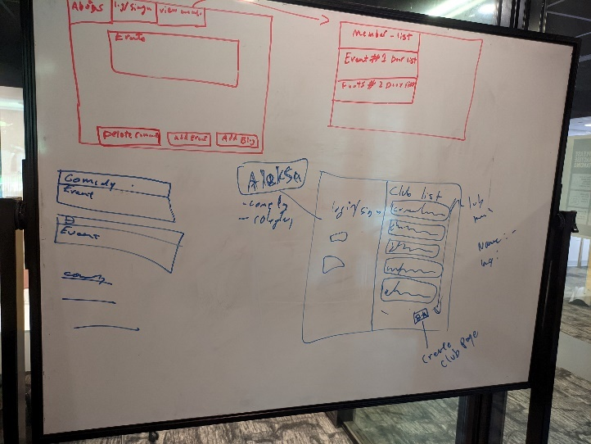

Figure : Initial sketches

At the first meeting, the group broke down the requirements available in the mid semester break. We produced a handful of primitive sketches outlining the possible pages and popups that would be included in a student club platform. The following pages were brainstormed:

* Club discovery/explorer page which hosts
  + a list of student clubs
  + includes a brief description about each club
* Club page which houses
  + Main page
    - Upcoming and past events
      * Can be edited by the manager
      * Users can book upcoming events
      * Users can expand the description of past events to read more about them (kind of a like a blog or article about previous events)
    - Latest forum or chat room posts
    - Navbar
  + Blog page
    - Can be directed to via expanding past events or house events that are no longer shown on the main page
  + Forum or chatroom page
    - Separate discussions
    - User needs to be logged in for this (can only use if you are part of the club)
  + About page
    - Brief on the club and houses contact information, all which can be altered by the manager of the club
  + Member list page
    - Viewable by the manager
    - Can select and do actions to members
* Login/sign up page (this could also be a pop up)
  + Login
    - Asks for username/email and password
  + Signup
    - Asks for full name, student id, preferred email, a password and possibly mobile number

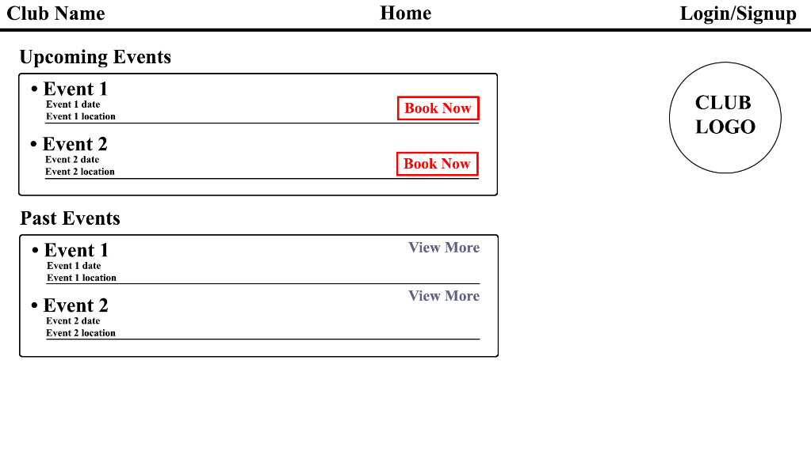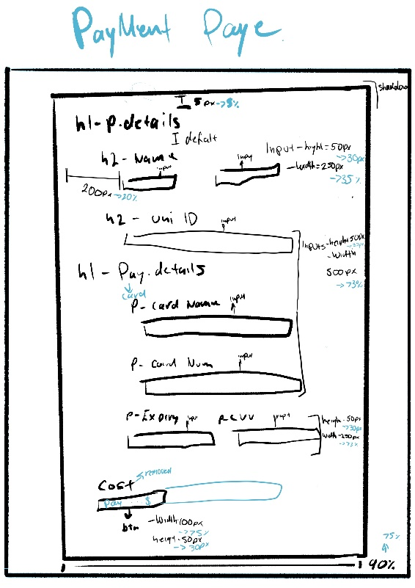A better sketch was designed in Photoshop on the day of the meeting to illustrate a possible layout for the main page of a club. The design is quite ugly. However, the navbar and club logo are good ideas that are common across many modern websites, as seen in the research section. The ‘Book Now’ buttons are apparent, which aids in accessibility. However, the lack of font hierarchy can confuse users, and much-wasted space exists. There is also a distinct lack of consistency with borders which makes the site look unprofessional.

Figure : The first use of dimensions in design

Figure : First digitally created design

The same week the idea of a payment page was brought up, as when a booking is placed, payment is required. The sketch does not have an accurate scale; however, it includes fixed and relative dimensions, which are great for implementing the designs. Additionally, the style for each piece of text is included to further aid in implementation. Including dimensions and styling will be expected in later sketches.

The designing process is quite tedious as the website aesthetic must be agreed upon by all members to allow for consistency across the web app and be appropriate for the user base.

## 2.2. Review, Reflect, and evaluate: The iteration of Club Main Page

The page which underwent the most changes was the main page for each club as it was hard to decide on the template which users would spend the most time on.

Figure : Main page, iteration 2

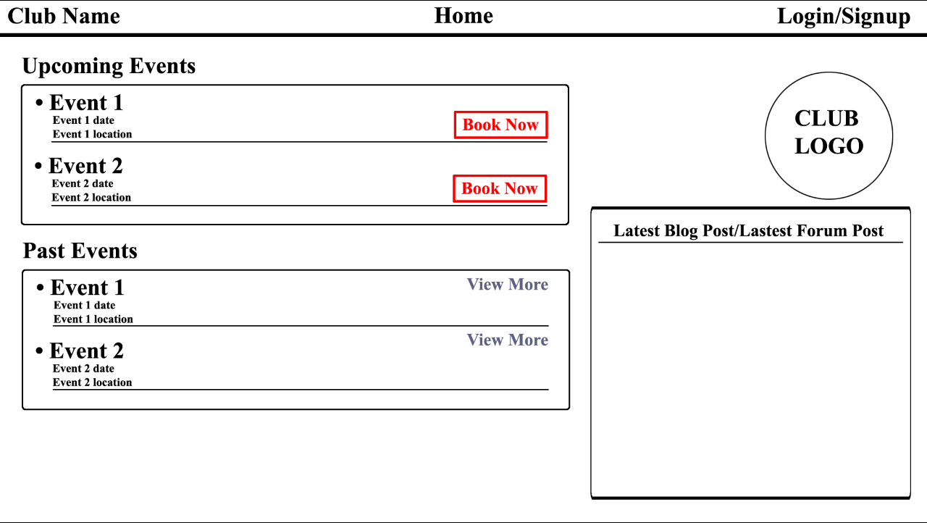To try and utilise the space more, a ‘top forum/blog posts box ‘was added, which would house either the latest or top-rated posts from the forum or sections of blogs from the blog page. The design decision was created from perceived necessity and inspiration from sites with extra content, such as XDA Developers, reddit.com, StackOverflow, and Pinterest. Boxes were a typical pattern along popular websites, so it seemed like a good idea to follow suit.

Figure : Main page, iteration 3

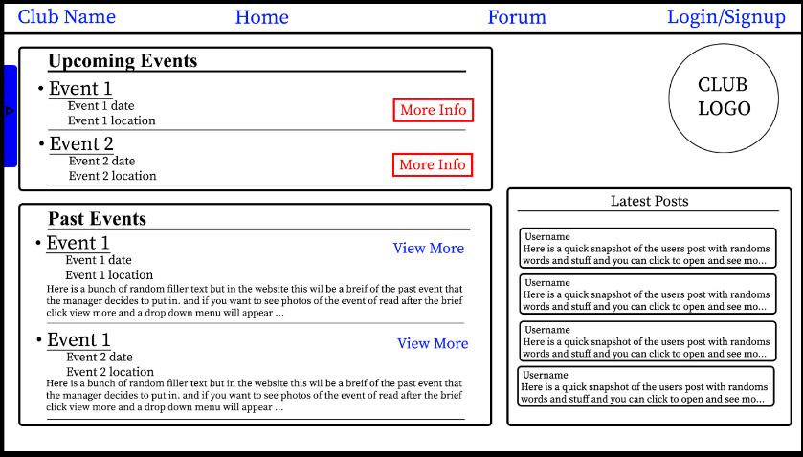The group realised the truly horrendous nature of the design, and we started using the term ‘mock-up’ to describe our designs. The third mock-up of the main page considered the pleasing nature boxes that end at the same height, included filler data to make the mock-up seem alive, allowing the mock-ups to be more easily evaluated as a webpage, included colour for the navbar items to so that they are different to text, changed the view more buttons to the same colour to increase contrast and show that similar action will occur when clicking either view more or navbar buttons. Additionally, a blue tab was added to the left-hand side, which would be used as a clickable tab that opens to display the about us page/text. We decided clubs probably would not require a new About page, so we went with the about us pop-up instead. We soon found that saying “we will add dimensions later” was wishful thinking that, if materialised, would have saved us many headaches..

Figure : Static html for main page based off iteration 2

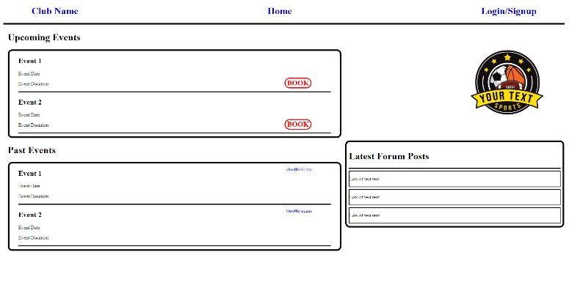 For some unexplained reason, we tried going straight from this mock-up to a static html page. As we were only able to gauge what the page should look like rather than what its requirements were, there was a lot of trial and error and ultimately so many revisions to the html and CSS that did not go any further than ‘good exercise’ and ‘proof of concept’. Parts were initially missing, and adding new parts led to issues within the page; however, it was not a complete waste as it did redirect us back a few steps to ensure we developed the page correctly and, most importantly, more feasible way.

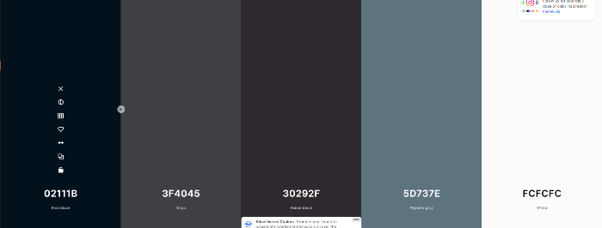 We took a step back away from VScode and back towards the drawing board. Iteration 4 included a colour palette and dimensions, and the group chose sans-serif as the font to be used. The colour palette was initially randomly generated seen in Figure 8. Its minimalism and high contrast justified the colour palette; however, it needed more variety and blandness that made pages look flat. The design iteration at this point had been overwritten, and no copy exists. However, a simulated example is seen in Figure 9.

Figure 9: main page, Simulated iteration 4

Figure : original colour palette

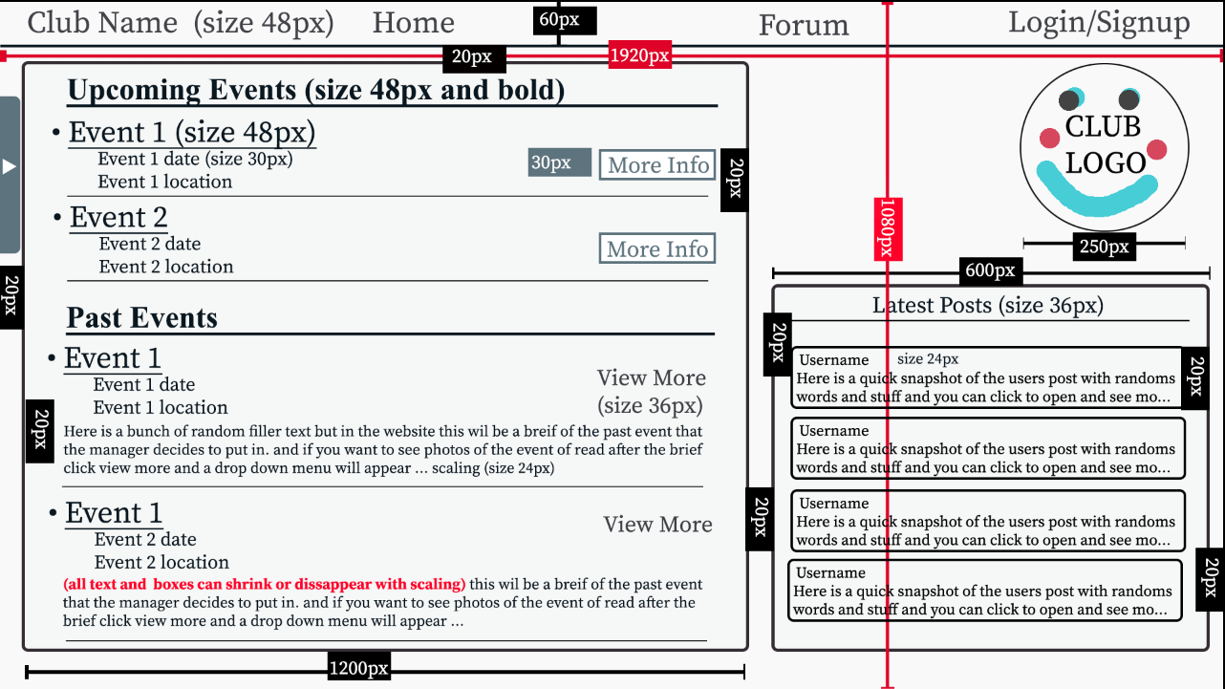Colour scheme at this point:

Text: #02111B:

Background: #FCFCFC

call to action elements: #3F4045, #5D737E

Border colour: #30292F

One of the group’s members was enthusiastic about including more greys and beige in the colour palette. These colours added depth and hierarchy to elements without being intrusive, distracting, or overwhelming.

Colour scheme at this point:

Text: #02111B

Background (different for box background colours, etc): #FCFCFC, #F5F5DC, #B8ADAD, #CBBFBF

Call to action elements: #3F4045, #5D737E

Border colour: #30292F

Figure 11: main page mock up showing view more feature of iteration 5

Figure 10: main page, iteration 5

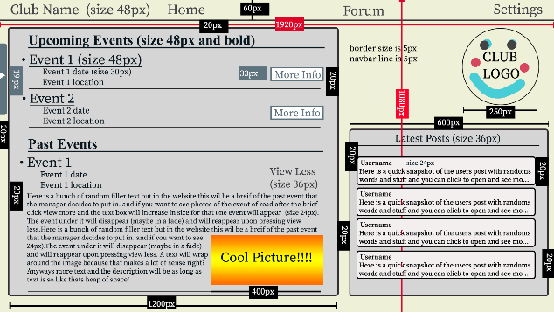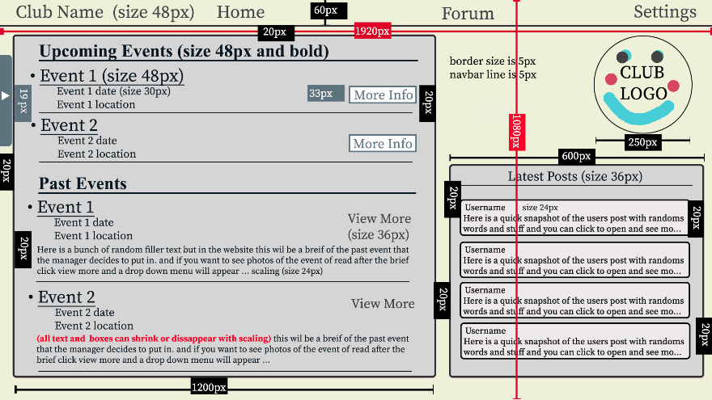

Iteration 5 included the updated colour palette. The colours are much warmer, which is more relaxing for the eyes. As clubs would be interested in getting users to click on the newest events, the ‘book’ button was changed to ‘more info’ and is white. Hence, it stands out and attracts users, similarly to the latest posts boxes, as convincing users to look at these boxes will show that the club is live and running, bringing a sense of community. Iteration 5 was when dimensions and text styling were added to the mock-up to allow for more straightforward interpretation when implementing the designs. Though the mock-up is cluttered, steps were taken to ensure that 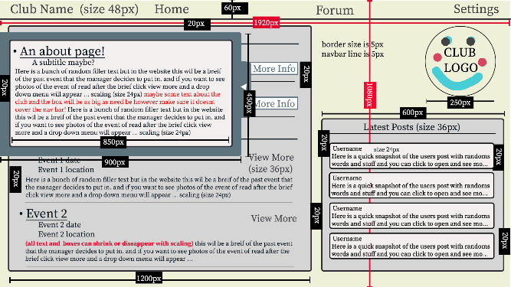dimensions were added thoughtfully, i.e. placing padding dimensions as single boxes between two elements and colour-coding view window dimensions. To further aid in implementation, mock-ups were made to display what would happen when a feature is accessed; figureFigures 11 and 12 show the view more and about us pop-up features, respectively.

Figure 12: main page mock up showing about us feature of iteration 5

Now satisfied with our Iteration 5, we decided to ask the least tech-savvy and most kinetically and cognitively challenged people we could reasonably access. We asked our parents for honest criticism. Upon explaining that the random boxes with text are not part of the final page, we were able to record information regarding the useability, accessibility, and other general information regarding the mock-up

Summary of criticisms:

Hurts eyes and neck to look back and forth between events and the latest posts

Too much stuff at one time

Fortunately, we also got some shared compliments:

The colours are nice and warm and are easy on the eyes

Text sizing is appropriate

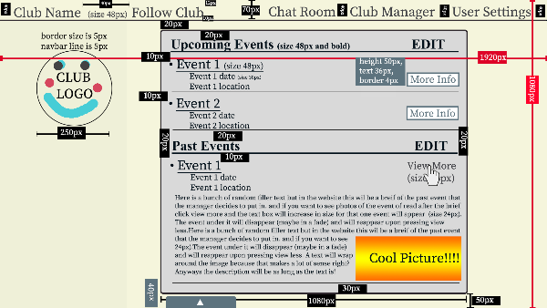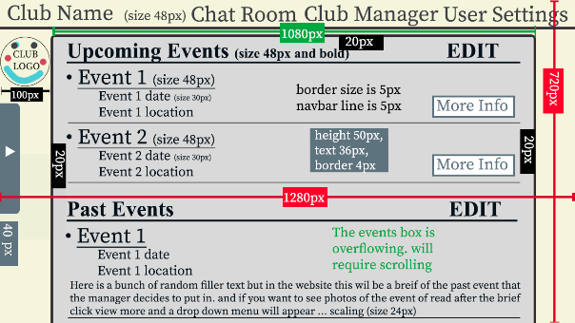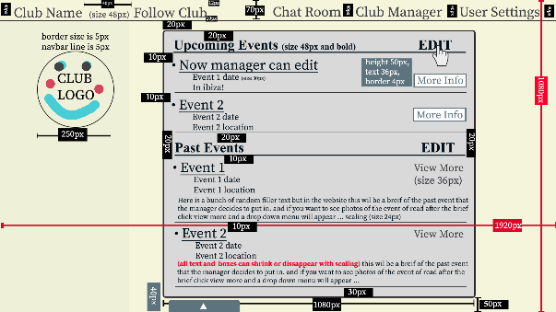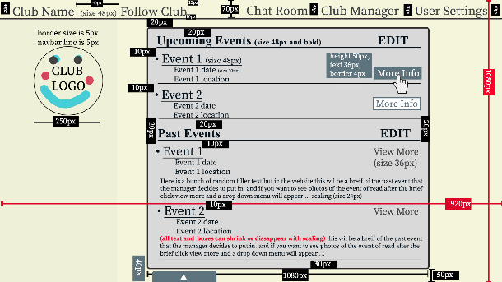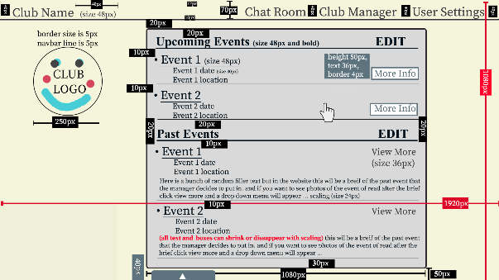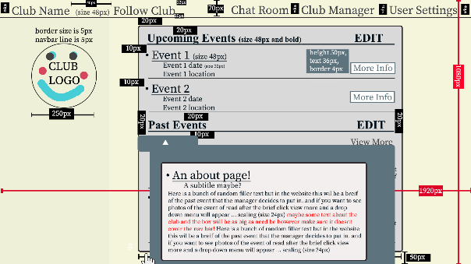We came back together as a group and agreed to remove the latest posts box from the main page as it would reduce clutter and, as we found out, helped with scaling. Iteration 6, along with the features of expected actions, was born through the information gathered.

Figure 13: main page mock ups showing Iteration 6 and its features

Iteration 6 was designed from a manager's perspective, showing all the elements that will be required in the static html page. If a user were to view the page, certain elements, such as club manager and 'EDIT', would be hidden/removed entirely. Additionally, some name changes, such as forum to chat room and settings to user settings, were made to ensure that users would better understand what each element of the navbar did. Removing the latest post box and centring the events provides a similar experience to the websites that we had researched, making the website more accessible and familiar to navigate, reducing the performance load on the user while also making it easier to implement scaling as the empty sides can shrink or expand without altering an essential element, the event box. Additionally, though not shown via a mockup, most phone screens are usually around 1080 pixels across when held portrait. By centring the event box and removing the latest posts box, we effectively made the site mobile-friendly (to some degree). A minor change was removing the home button, which was the same as the club name button—no point in redundancy. However, typing now, we will need a button to get back to the club directory; oops.

### Iteration 7:

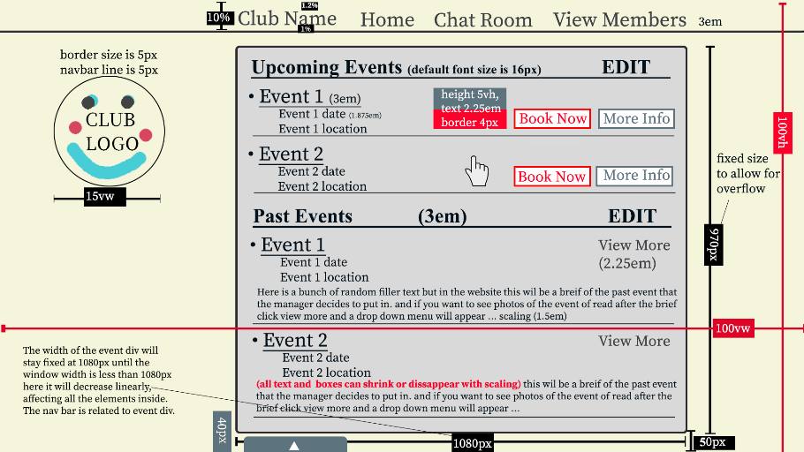 When asking for a review of our current designs, one of the tutors (or maybe the course coordinator) told the group to make sure dimensions were relative (where applicable). Additionally, cross referencing with the required features on the data plan Iteration 7 was made. The return of the home button, the substitution of ‘club manager’ for to ‘view members’ button and the removal of the ‘user settings’ button (as that could be accessed from the home page), allowed the club home page template to have features and functions with purpose rather than being created due to the possibility of being required. The return of the ‘book now’ button made RSVP’ing a lot easier and reduced the number of steps required for a user to complete a fundamental function. Additionally, each feature is now correctly labelled and describes its function more succulently and accurately, aiding in accessibility and useability (along with helping with implementation). Iteration 7 is the final iteration before milestone 1.

Figure 14: main page mock ups showing Iteration 7

A deeper review of Iteration 7 is found in the Design section (Section 3.).

# 3. Design - Final Review Against UX Principals

## 3.1.Home Page for users , admins and club managers

New users are greeted with text instructions in the event box centred when first entering the website. The instructions will inform the users that they should sign up/login. Logged in users can follow clubs in order to be able to see that club’s events on the user’s homepage. (note that the admin button is only visible to admins who have logged in). Following the advice from a reviewer who suggested that popups would make the website's purpose more transparent instead of having random clubs' events. This is also in line with UI principles. In particular, this will reduce the cognitive load once the user has signed in and has followed the clubs. They can then see the latest posts and events by the clubs in the centre. The structure was influenced by Reddit and Instagram, where followed account's posts are shown in the feed.

On the top right-hand corner of the website, there is a login/sign-in button that, once pressed, takes users to the login/sign pop-up. We decided to put the button on the right-hand corner as it is consistent with the websites that we reviewed. Because it is consistent, users would expect the log in button to be there due to their experience with other websites, in turn reducing the cognitive load. Additionally, admins have their setting button that takes to a separate page to manage clubs.

Next to the login/sign-in button is the settings button, which is intentionally positioned, using Fitt’s Law, near the log in button to reduce the kinematic load.

Once pressed, users are taken to a separate page for settings.

On the left-hand corner of the website, we have a button that prepares a pop-up will appear that displays the clubs they can follow.

Both buttons are intentionally chosen to be significant as they are standard tools for the user to navigate the website. Having the big means they are easier to interact with.

As suggested by some of our participants in an informal survey, having two settings made using the website slightly more challenging for the Admin. However, we decided to keep the settings for the Admin, as having just a "setting” button for admins would decrease the intuitiveness and consistency of the site for an Admin.

Throughout the homepage, we aimed at making the following clubs and sign-in pages a pop-up, as it reduces the number of pages that the user needs to go through, which reduces the cognitive and kinematic load of our website. Furthermore, in our final survey, users agreed that the website is "minimalist and easy to use”.

## 3.2. Follow Clubs popups

In the pop up, a list of clubs will be shown. On the upper part of pop up, the followed club lists is shown and on the bottom part, the clubs available to follow is displayed

Home button is still shown, in case the user wants to exit the pop up.

## 3.3. Sign up and log in pop ups

When the button signup/log in is pressed, the initial pop-up that requests email, Full name, username and password is shown. Underneath there is a “Have an account?” button. This is like the log in of Riot Games and Reddit, as when the user initially goes to their website, they assume the user is not registered and requests full name, email, etc. Like ours, those websites can log in underneath the request to register. We designed our log in and signup to be consistent, reducing the cognitive load. On the top, “Register ” is shown to let the users know if they are at the log in or signup. As mentioned before, these are standard practices that other websites have done and reduce cognitive load.

## 3.4. Settings page

Users, club managers and admins have the same settings page.

Users can scroll through the options to change their username, name, birthday, gender, signup details, and connected accounts and remove themselves from a booked event. The options box is centred, making scaling the website more accessible for a mobile phone. However, this increased the kinematic load of our website as users needed to scroll down to find their desired option.

As noted previously in our research section, Riot Games has heavily influenced the setting part, as we found it straightforward to use. Furthermore, the way the setting page is scaled was also influenced by that design.

It is also important to note that before entering the settings, users are required to log in to their account if they are not already logged in. This is to increase the web app's security further.

## 3.5. Club Home Page

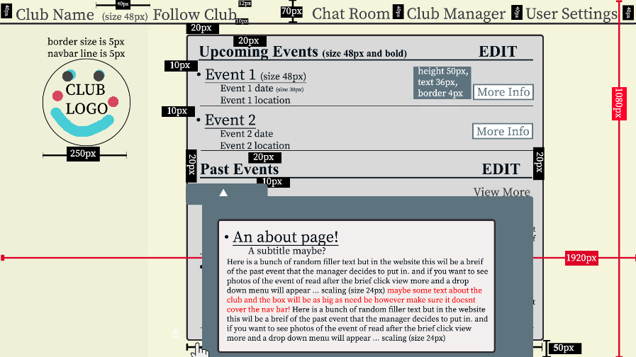Every club will have a home page based on the above templates. The top left most mock up, is the latest Iteration (with the correct relative dimensions in em**),** however the other 5 mock ups are based on Iteration 6. They are provided to illustrate the features of the page; the view more feature, the about us pull out, scaling, edit, more info (which has a similar property to book now). The club home page takes a centre heavy approach to web design to reduce kinematic load (by decreasing distance between elements), increase useability across platforms and devices (by only using the most common width across devices), and reduces cognitive load by only including relative material in each page. The centre-based approach is consistent across the webapp, and common across other webapps on the internet, see *Research*. This further reduces cognitive load and makes the page familiar to new users which aids in accessibility, useability, and reduces the investment required to learn the page which helps keep users returning.

## 3.6.Chat room (extra feature)

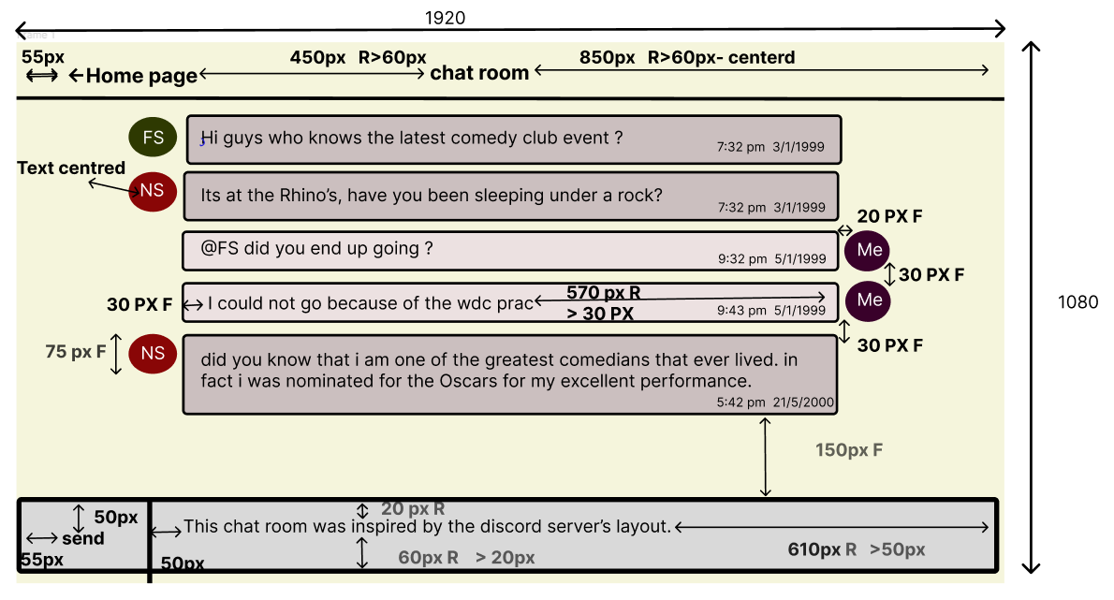

Each club page will feature a chat room after the logged-in user presses the chat on the club’s page. The chat room was initially a forum. However, due to time constraints, we decided to make it a chat room with similar features to discord servers for a group. THE design is intuitive based on the discord app. (To clarify the dimensions provided, R stands for relative, and F stands for fixed. When the diagram shows >20px, that means the minimum of that length to the border of the page will be 20 px).

## A screenshot of a computer Description automatically generated with medium confidence3.7. View members

As mentioned, club managers have settings that can search for a user and remove them from the club. The settings page has a “Find User” bar allowing the club manager to enter the user ID or name. The club manager needs to press the “search” button to locate the user. Once pressed, the user’s name, username, user ID and events attending are shown. Despite the limited resources available to research this page, most people in our survey found this page intuitive. The choice of colour red and bolding of the “Find user” improved the main box was centred so that the website would scale nicely on mobile phone.

## 3.8. Admin Settings Page

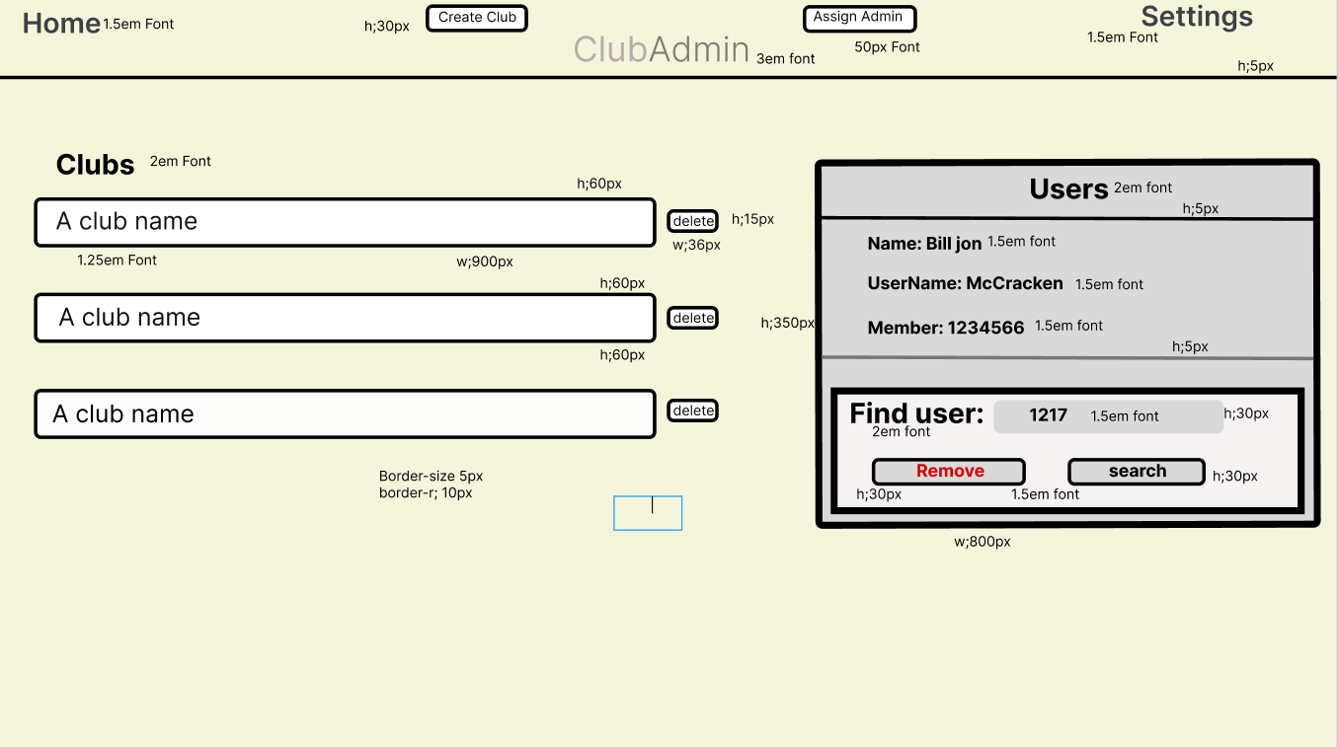

Clubs admin page is very similar to the club manager page. As described previously, the admin is able to locate a user and remove them via the purple box on the right.

Admins are also able to delete or create a club. Unfortunately, it was found that this page was weakest page in terms of kinetic and cognitive load . As the admin needs to scroll down to find a particular club . Further to this , the buttons for creating a club and assigning a club are located in the top which is not consistent with the rest of the website design. However, we have already planned to improve this design by having another box like the one on the right. We would put that box on the left side and similar to the box on the right, the admin is able to search and delete a club . The button to assign an admin will be underneath that box.

With that improved design , the website would also scale better as when on mobile, the two boxes would align vertically underneath each other and the admin would scroll to the boxes .

# 4. Discussion of Features

Starting from the home page in the centre, we have a live feed displaying the most recently posted events from followed clubs. Upon signing in, this will update to display the user's followed clubs' most recent event posts. For first-time users, this page will only show the most recent events; the sign/up button will prompt a new user to register, which asks the user to input their UserName, FullName, Email, and password. The sign-in option also has a section for if a user has forgotten their password; this will send an email to the user with a new password for them to log in . A user will see the home page containing the 'Find Clubs' and the 'Settings' buttons. The Settings button loads the user settings page, which is identical for all users, admins, and managers. On this page, the user can change their username, gender, password, and email.

Moreover, they can view what events they have shown interest in. The settings page has a navigation bar with specific icons for the desired sections. Once signed in, any page can access the 'Settings' page, and the exit button will take the user back to the previously viewed page.

On the 'Home' page, managers will see the same as the user and have no extra permissions on this page.

Suppose an Admin is signed in on the 'Home' page. In that case, a hidden button is displayed, which takes the admin user to the 'Admin Control Page'. Here the Admin user can create a new club, delete an existing club, find any user, and Assign Admin Privileges to a user.

Back on the 'Home' page, the user can search for Clubs via the 'Find Clubs' button, which produces a popup listing all current clubs; if they have joined a club, these are at the top of the list and are under the label Joined Clubs. Clicking on any club, whether the user has joined or not, will take the user to the club's main page. Here the user will see information about the club's latest events and the option to view more information about the event. Below that is the club's previous two events and a short description. If the user wants to know more, the view more buttons will produce and drop-down with uploaded images from the event and more information if it was provided. The user, if new to the club, can choose to follow the club; once followed, the 'Chat Room' option will appear, where the user can interact with other fellow members' managers, and the admin user has the option to delete specific messages from the chat room if they feel it appropriate. Back on the Club page, Managers and Admins have hidden buttons for editing the Club image, Upcoming events, and Past events; these allow the manager to update the current events and editing the upcoming events will allow the manager to delete or add a new event which will also update on the main page. This is the Same for the Past events; however, these are not displayed on the main page. Editing the club image will allow the manager to upload an image for their club. Managers and Admins also have the 'Club Manager' option appears, which opens the page Club Manager page; here, the Managers and Admins can see all the users following the club with the option to remove users. Admins and Managers have a button on this page, 'Make User Manager'. Here, they can give manager permissions to a user. Along with a delete Manager button to remove the manager permission from a manager. The back buttons will take the user back to the previous page, and the home button will take the user back to the home page.

# 5.Conclusion

The design process commenced with thorough research into designing a web application for student clubs. This involved understanding the needs and behaviours of the intended users - the students - and investigating the range of functionalities that would benefit them. We also studied existing solutions to identify what worked well and what could be improved. Following this research phase, we conducted a comprehensive review, evaluating our findings and using them to inform our design decision. Next, we dove into the latest design trends and best practices in web applications, ensuring our design would be modern, intuitive, and visually appealing. We then engaged in detailed discussions of specific features to be incorporated into the app. These discussions were centred on how to best integrate these features in a manner that would be user-friendly and provide optimal benefits to the student clubs and their members. This iterative process of research, review, design, and discussion ensured the creation of a web application tailored specifically to the needs of university student clubs and the end user.